1] image acquisition and representation

Code :

import cv2

path = 'E:/pranav sirsufale/spidy.jpg'

img = cv2.imread('spidy.jpg')

cv2.imshow('image',img)

cv2.waitKey(0)

cv2.destroyAllWindows()

**OUTPUT:**

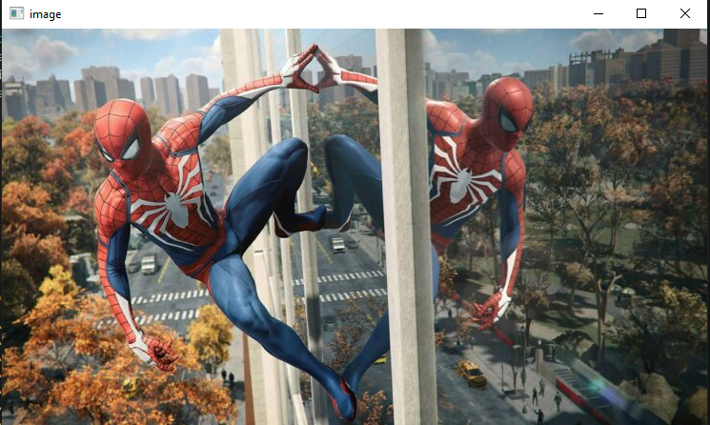

2] image compression and storage.

Code :

### Image compresson and storage

import cv2

img = cv2.imread('spidy.jpg',1)

compressed_img_param = [cv2.IMWRITE_JPEG_QUALITY,50]

cv2.imwrite('compressed_sharp_img2.jpg',img,compressed_img_param)

OUTPUT:

|  |  |
| --- | --- |
| ORIGINAL IMAGE | COMPRESSED IMAGE |

3] image filtering and Restoration – Spatial domain filtering, Frequency domain filtering Image denoising and restoration.

Code :

import cv2

import numpy as np

img = cv2.imread('noicy.jpg',0)

denoised = cv2.GaussianBlur(img,(5,5),0)

cv2.imshow('original Image',img)

cv2.imshow('denoised iamge',denoised)

if( cv2.waitKey() == ord('q') ):

    cv2.destroyAllWindows()

OUTPUT:

|  |  |
| --- | --- |
| ORIGINAL IMAGE | DENOISED IMAGE |

4] Convert bright image into dark image.

Code :

import cv2

brigh_image = cv2.imread('fish.jpg')

darkening_factor = 50

dark_image = cv2.subtract(brigh_image, darkening_factor)

dark_image = cv2.max(dark_image,0)

cv2.imshow('Original Image',brigh_image)

cv2.imshow('Dark Image', dark_image)

cv2.waitKey(0)

cv2.destroyAllwindows()

OUTPUT :

|  |  |
| --- | --- |
| ORIGINAL IMAGE | DARK IMAGE |

5] image compression and storage.

Code :

OUTPUT :

|  |  |
| --- | --- |
| ORIGINAL DARK IMAGE | NEWLY BRIGHTED IMAGE |

4] image compression and storage.

Code :

OUTPUT :